

**Report of B.Tech Project 2018**

Demand Analysis and Service Enhancement of Auto Services inside BHU

**Under the guidance of:** Dr. P. Bhardwaj

|  |  |
| --- | --- |
|  | **Team Members:**  Vikrant Singh Mahawar  Girhe Ankit Gulab  Prabhat Vardhan  Karampal Yadav  Karan Singh Meena |

**Acknowledgement**

We would like to express our special thanks of gratitude to respected Dr P. Bhardwaj who gave us the golden opportunity to do this wonderful project on the topic “Demand Analysis and Service Enhancement of Auto Services inside BHU, which also helped us in doing a lot of Research and we came to know about so many new things we are really thankful to them.

We greatly appreciate the motivation and understanding extended for the project work, Dr. Bhardwaj sir who responded promptly and enthusiastically to our request for frank comments, despite his congested schedules. We are very thankful for his guidance.

**Introduction**

The objective of our project is to improve our existing travelling auto services inside BHU, i.e. we are analysing demand of customer for auto from different location inside BHU, analysis of source and destination of their journey. And analysis of demand of auto drivers to increase their daily earnings and reduce uneven distribution. In result, we are trying to develop quality of service time of auto drivers, working on increment of earning of auto drivers, helping them in getting customers.

Our service is bilateral in nature and hence serves both customers and auto drivers. We are developing an android application which will help customers to find auto with less effort and it will also help auto drivers to find customers and increase their income.

Using application the customer will send a request for auto, depending on the position of auto in queue the auto driver will receive a notification, which he will accept on his wish. The customer will provide his source and destination in request. By accepting the request of customer, auto driver will report to the location of source and pick up the customers.

When the auto gets full, the auto driver will remove himself from network of app, in this way the next auto driver in queue will be added as head of queue inside app and he will get the next notification and so on. Inside app the customer will have different choices for getting auto normal or instant, if he have call auto instantly he will have to book entire auto.

Request will remain active for some time with active driver on network, if he doesn’t respond the request in that time period, the request will be forwarded to next auto driver in queue and the former will be removed from network.

**Survey**

We have surveyed over different locations of BHU auto service. The data for different locations is as follows:

(Note : a single bracket represent a single auto number inside bracket represent number of people inside auto)

1. Hyderabad Gate

Survey on Jan 20th , 2018

|  |  |  |  |  |  |
| --- | --- | --- | --- | --- | --- |
| .no. | Started on | Auto at stand | Coming | Going | Passing |
| 1 | 1:48 pm | 15 | (1) (0) (0)(3) | (5) | (4) (0e) (2) |
| 2 | 1:53 pm | 18 | (2) | (5) (0) | (3) |
| 3 | 1:58 pm | 17 | ----- | (5) | (4) (0) (2) |
| 4 | 2:03 pm | 16 | (1) | -------- | (4) (0) (0) (0) (0) (0) |
| 5 | 2:08 pm | 17 | ------ | (5) | (4) (4) (5) |
| 6 | 2:13 pm | 16 | (1) (0) | (5) (5) (4) | (4) (2) (4) |
| 7 | 2:18 pm | 15 | ------ | ------- | (0) |
| 8 | 2:23 pm | 15 | (2) (2) | (3) (4) | (5) (4) |
| 9 | 2:28 pm | 15 | ----- | ----- | (0) (5) |
| 10 | 2:33 pm | 15 | ----- | (4) (3) | (3) (4) (1) (5) |
| 11 | 2:38 pm | 13 | ----- | (5) | (3,2d) (0) (0) |
| 12 | 2:43 pm | 12 | ----- | (4) | (3) |
| 13 | 2:48 pm | 11 | (1) | (5) (4) | (3) (1) (5) |

* 1:48 pm 1 auto waiting with 1 passenger +1+1+2 go at 1:57 pm. (9 min)
* 1:58 pm 1 auto waiting with 2 passenger+3 go at 2:01 pm. (3 min)
* 1:57 pm go and stand in front of SN BOSS
* 2:01 pm 1 auto waiting with 1 passenger+1+3 go at 2:08 pm. (7 min)
* 2:09 pm 1 auto waiting with 2 passenger+3 go at 2:15 pm. (6 min)
* 2:11 pm 1 auto waiting with 4 passenger+1 go at 2:16 pm. (5 min)
* 2:13 pm 1 auto waiting with 2 passenger+2 go at 2:17 pm. (4 min)
* 2:17 pm 1 auto waiting with 2 passenger+2 go at 2:26 pm. (9 min)
* 2:18 pm 1 auto waiting with 2 passenger+2 go at 2:35 pm. (17 min)
* 2:20 pm 1 auto waiting with 2 passenger+1 go at 2:37 pm. (17 min)
* 2:36 pm 1 auto waiting with 3 passenger+2 go at 2:39 pm. (3 min)
* 2:40 pm 1 auto waiting with 1 passenger+3 go at 2:43 pm. (3 min)
* 2:43 pm 1 auto waiting with 1 passenger+3+1 go at 2:48 pm. (5 min)
* 2:47 pm 1 auto waiting with 3 passenger+1 go at 2:52 pm. (4 min)

|  |  |  |  |  |  |
| --- | --- | --- | --- | --- | --- |
| S. no. | Started on | Auto at stand | Coming | Going | Passing |
| 1 | 9:06 am | 13 | (0) (0) | (5) | (1) (2) (5) (2) |
| 2 | 9:11 am | 14 | (0) (0) | (5) (5) (5) (5) | (0) |
| 3 | 9:16 am | 12 | --------- | (5) | (3) (2) (1) (1) |
| 4 | 9:21 am | 11 | (0) | (5) (3Re) | (1) (4) (5) |
| 5 | 9:26 am | 10 | (0) | (5) (5) | (5) (1) (3) |
| 6 | 9:31 am | 9 | (0) | (5) (0) | (4) (5) (1) |
| 7 | 9:36 am | 8 | (0) (0) | (7) (5) | (2) (5) (5) (0) |
| 8 | 9:41 am | 8 | ----- | --------- | (2) (5) |
| 9 | 9:46 am | 8 | (0) (0) (0) (0) (0) (0) | (6) (5) | (1) (1) |

Survey on Jan 29th , 2018

* 9:06 am 1 Auto waiting with 2 passenger +3 go at 9:08 am. (2 min)
* 9:08 am 1 Auto waiting with 1 passenger +1+3 go at 9:12 am. (4 min)
* 9:15 am 1 Auto waiting with 1 passenger +4 go at 9:17 am. (2 min)
* 9:20 am 1 Auto waiting with 1 passenger +3 go at 9:22 am. (2 min)
* 9:22 am 1 Auto waiting with 2 passenger +1+1+1 go at 9:26 am. (4 min)
* 9:26 am 1 Auto waiting with 1 passenger +1+1+1+1 go at 9:28 am. (2 min)
* 9:28 am 1 Auto waiting with 1 passenger +1+3 go at 9:31 am. (3 min)
* 9:31 am 1 Auto waiting with 1 passenger +1+3 go at 9:33 am. (2 min)
* 9:33 am 1 Auto waiting with 1 passenger +1+3 go at 9:36 am. (3 min)
* 9:36 am 1 Auto waiting with 3 passenger +1+1 go at 9:40 am. (4 min)
* 9:41 am 1 Auto waiting with 2 passenger +4 go at 9:47 am. (6 min)
* 9:47 am 1 Auto waiting with 1 passenger +2+2 go at 9:49 am. (2 min)

Survey on Jan 31th , 2018

|  |  |  |  |  |  |
| --- | --- | --- | --- | --- | --- |
| S. no. | Started on | Auto at stand | Coming | Going | Passing |
| 1 | 3:40 pm | 13 | ------- | --------- | (5) (0) (4) |
| 2 | 3:45 pm | 13 | -------- | -------- | (5) (5) (3) (0) (0) (1) (0) (0) (0) (0) |
| 3 | 3:50 pm | 13 | -------- | (5) | (4) (2,1d) |
| 4 | 3:55 pm | 12 | (0) | (5) (0) | (4,1d)(0) (1) (1,1d)(5,3d) |
| 5 | 4:00 pm | 11 | (0) | (6) | (6) (3) (0) |
| 6 | 4:05 pm | 11 | (2) | (5) | (0) (5,3d) (4,2d) |
| 7 | 4:10 pm | 11 | ------- | (5) | (0) (1) (4,2d) (5) (0) |
| 8 | 4:15 pm | 10 | -------- | (0) (5) | (2,2d) (5,3d) (5) |
| 9 | 4:20 pm | 8 | (4) | (5) | (4,2d) (2,2d,2p) (4) |
| 10 | 4:25 pm | 8 | (5)(0) | -------- | (4,2d)(4) (0) (4,1d) (0) |
| 11 | 4:30 pm | 10 | (0) | (5) (5) | (4) (4,3d) (3) |
| 12 | 4:35 pm | 9 | (1) | (0) | (3,1d) (2) |

1. Vishwanath Temple

Survey on Jan 21th , 2018

|  |  |  |  |  |  |
| --- | --- | --- | --- | --- | --- |
| S. no. | Started on | Auto at stand | Coming | Going | Passing |
| 1 | 1:43 pm | 7e, 10 | (3) | (0) (5) (3) | (0) (2) (5) (3) (2) (5) |
| 2 | 1:48 pm | 7e, 8 | (5) | (2) (3) (4) | (5) (0e)5 (4) (2e) (0,p3) |
| 3 | 1:53 pm | 7e, 6 | (5) (4) | (5) (0) (2) | (3,d1) (3,d1) (4,p1) |
| 4 | 1:58 pm | 7e, 5 | (0e) | ------- | (4) (3) (2,d2) |
| 5 | 2:03 pm | 8e, 5 | (3) (5) (4) | (5e) | (5) (4) (5) |
| 6 | 2:08 pm | 7e, 8 | ------ | (5) | (3,d1) (6,d2) (2) (0,p3) |

Survey on Jan 22th , 2018

Right side of VT

|  |  |  |  |  |  |
| --- | --- | --- | --- | --- | --- |
| S. no. | Started on | Auto at stand | Coming | Going | Passing |
| 1 | 3:00 pm | 3e, 6 | (3) | (4) (4) | (4) (3) (5) (0) |
| 2 | 3:05 pm | 3e, 5 | ----- | (4) | (3) (2) (5) (5,d2) (0) |
| 3 | 3:10 pm | 3e, 4 | (3) (0) (2)(0) (3)(3) | (5e) (3e) | (2) (1e) |
| 4 | 3:15 pm | 1e, 10 | ------ | (4) | (1) (1) (3) (0e) (0) |

Left side of VT

|  |  |  |  |  |  |
| --- | --- | --- | --- | --- | --- |
| Sr. no. | Started on | Auto at stand | Coming | Going | Passing |
| 1 | 3:24 pm | 3e, 2 | (5)(0) (2) (4e)(5e) | (5) (5) (4) (5e) | (5) (4e) (3e,d3) |
| 2 | 3:29 pm | 4e, 2 | (0) (0)(4) (2)(3e)4(0e) | (4e)(4) (5) (4e) | (2e)(3)(5) (5) (5)(4) |
| 3 | 3:34 pm | 4e, 4 | (0) (0) (5e) (5) (3)(2) (0) | (3e) (5e) (5) (3) (4e) (5) (4) (5e) (0) | (4) (5e) |
| 4 | 3:39 pm | 1e, 5 | (2) (5) (5) (5e) (2) (0) | (5) (4) (4) (2) (3) (3) (4) (5) | (3) (2) |

Survey on Jan 31th , 2018

|  |  |  |  |  |  |
| --- | --- | --- | --- | --- | --- |
| S. no. | Started on | Auto at stand | Coming | Going | Passing |
| 1 | 2:35 pm | 5e , 1 | (0) (0) (0) | (4) | (5) (5)(4) (5e) (3,1d) |
| 2 | 2:40 pm | 5e, 3 | (3) (0) (0) (0) | (4) (5) (4) | (1) |
| 3 | 2:45 pm | 5e, 5 | (5) | (3) (5e) (5) (7e) (5e) (5) (9e) (0) (3) | (5) (5,d3) (5e) |
| 4 | 2:50 pm | 1e, 1 | (5)(4) (0) (5) | (5) (5e) | (0,3p) (5) |
| 5 | 2:55 pm | 1e, 4 | (2) (0) (3e) | (5) (4) (1re) | (3,1d) (4,1d) |
| 6 | 3:00 pm | 2e, 4 | (0) | (5) (5e) (5) | (4) (2) |
| 7 | 3:05 pm | 1e, 3 | (5) (0) (2) | (5) (5) | (2,3p) |
| 8 | 3:10 pm | 1e, 4 | ----------- | (2) (6) (2) | (2,2p) (0,3p) (5) (2) (4) (0) (5,2d) |
| 9 | 3:15 pm | 1e, 1 | (3) (0) (4) (3) (1e) | (6) (3) | (3) (2,2d) (3) |
| 10 | 3:20 pm | 2e, 3 | (10e) | (0) (3) (5) (1re) (6) | (5,2d) (5) (3) (2) (0e) (6) |

1. Health Centre (20/1/2018)

* From 3:14 PM to 3:50 PM only three auto passes.
* No one comes to health centre that day (Saturday)

1. Lanka Gate :- (22/Jan/2018)

|  |  |  |  |  |  |
| --- | --- | --- | --- | --- | --- |
| S. no. | Started on | Auto at stand | Coming | Going | Passing |
| 1 | 3:42 pm | 5e, 4 | (4) (5) (6) (4) (4e) (7) (4) (5) | (3) (6) (4) (4) (5) (4e) (5) (4) (4e) (6e) | (5) (7) (5) |
| 2 | 3:47 pm | 3e, 4 | (5)(0) (6) (5) (5) | (4) (2e) (5) (5) (0) | (5) (6) (8e) (0e) (0e) |
| 3 | 3:52 pm | 2e, 5 | (5) (5) (5) (5) (5) (5) (2) | (0) (3) (0) (0) (1) (4) (5) | (0) |
| 4 | 3:57 pm | 2e, 6 | (5) (5e) (0) (2) (5e) | (1) (2) (4e) (5e) (4) (4e) (2) (3) (4e) (5) |  |
| 5 | 4:02 pm | 1e, 3 | (3) (0) (3) (3) | (4) (5) | (4e) (1) (5) |
| 6 | 4:07 pm | 1e, 5 | (0) | -------- | -------- |

1. Sheer Gate

* 4:13 PM to 4:42 PM
* There was not any single auto present
* There were 6 rickshaws there.
* Five got customer in half hour.

**Discussion with Auto Drivers**

We designed a questionnaire to know about auto drivers, their daily routines and problems faced by them, which gave us knowledge about their daily income, their income sources, android users, their service time.

The questionnaire is attached at the end of report.

The result of the discussion are:

* They have to wait more than one and half hour.
* Sometimes they have to leave with less than five customers.
* **Profit distribution of auto drivers at Hyderabad Gate**

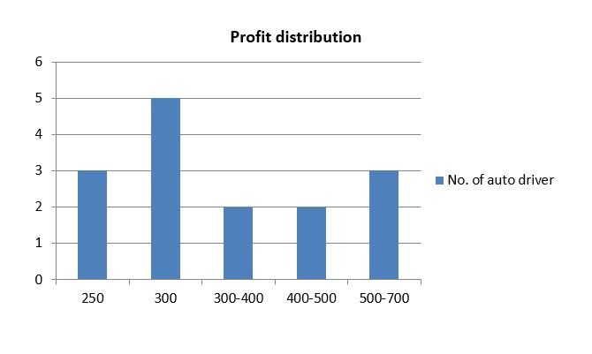

Average profit of auto drivers: Rs. 375 (approximately)

* **Profit distribution of auto drivers at VT**

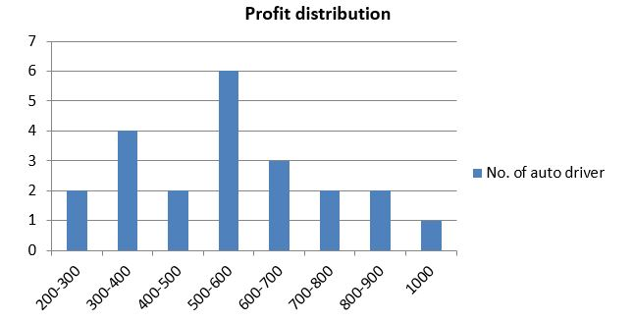

Average profit of auto drivers: Rs. 520 (approximately)

* Drivers at HG earns less than drivers at VT
* **Availability of auto at HG**

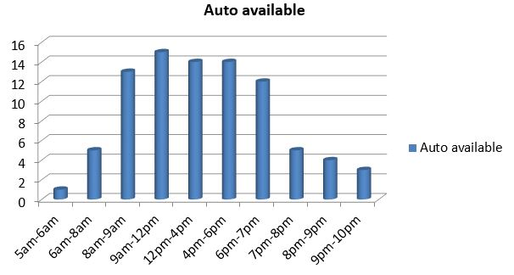

Maximum number of auto are available in between 8AM to 7PM

* **Android Users**

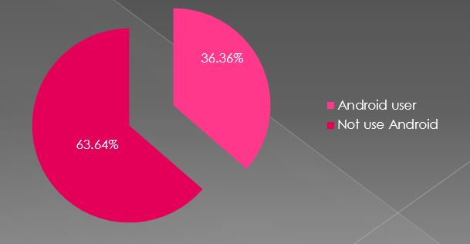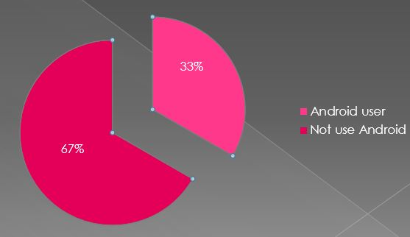

HG VT

**Data Flow Diagram of App**

Zero level DFD

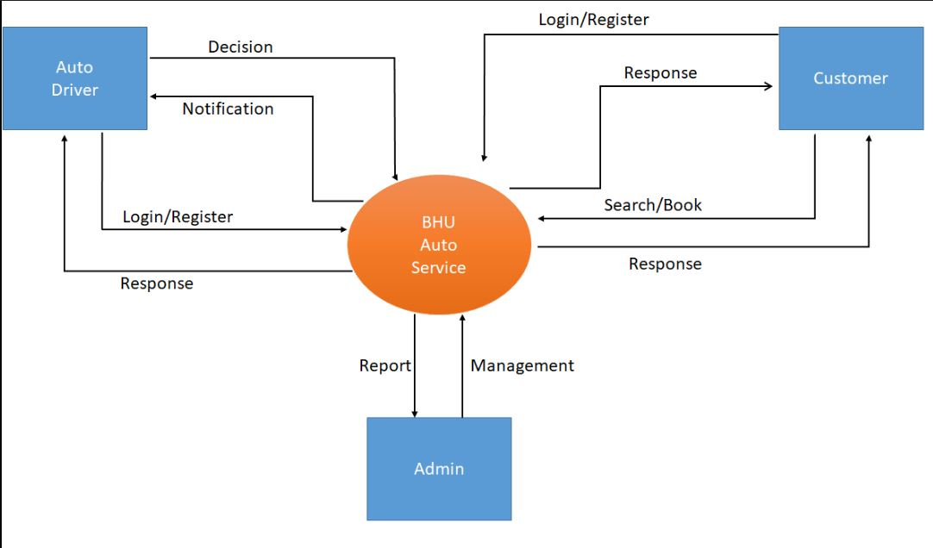

First level DFD

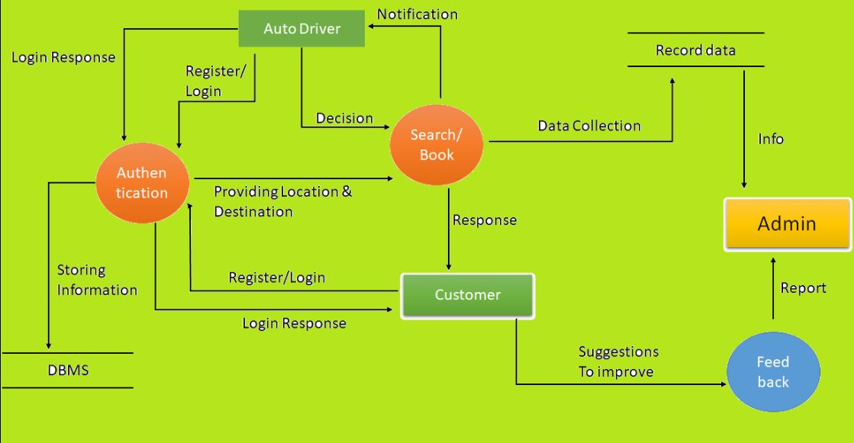

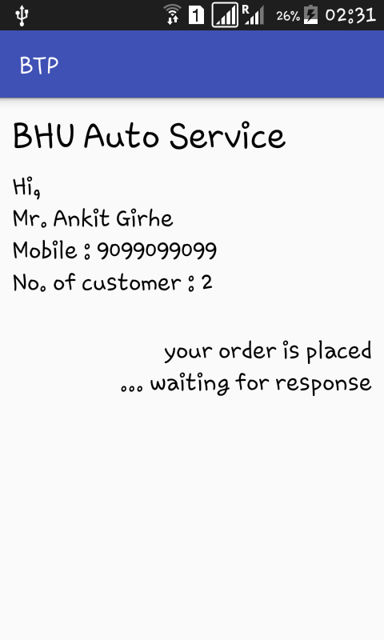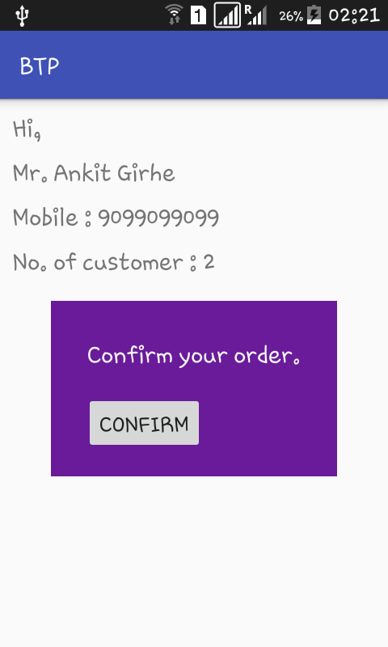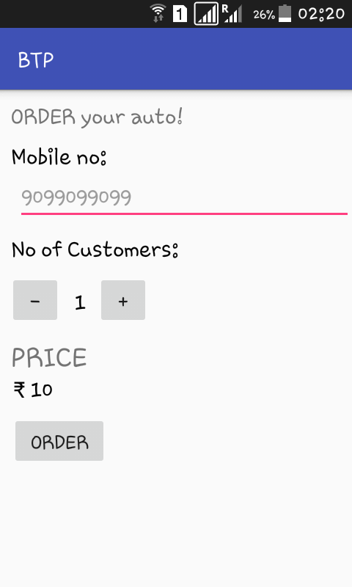**Android Interface**

**CONCLUSION OF SURVEY**

From this project we have analysed data, from different location of BHU. Every request obtained in app will be stored in database, the data will be used to forecast that in what time of day, from which location and how many customers are ordering auto. By getting this information we will be able to analyse that demand, then we can send auto there for those time so that the service will be improved.

1. At VT average waiting time of an electric auto is 15 minutes.
2. At HG average time duration between 2 trips is 1 hour.
3. Maximum waiting time for a passanger at HG is 10-12 minutes and minimum time is 5-6 minutes.
4. At HG almost all auto goes with full capacity therefore no vacancy for passangers at hostel or some other location.
5. Sometimes auto goes without passanger regardless of more waiting.
6. At noon waiting time for passangers is more and vacant seats also more.